This report analyses the sales performance of four water product categories - Mineral Water, Enriched Water, Flavoured Water, and Spring Water - across the North, West, and East regions over a six-month period. It aims to identify sales trends, regional preferences, and product performance to inform strategic decisions.

**Findings**

Spring Water is the leading product across all regions, with the highest sales recorded in the East (9,030 units, average 1,505/month).

The East region leads in sales for all product categories, indicating a strong market or preference.

Flavoured Water performs significantly better in the East (average 826 units/month) compared to North and West, suggesting regional preferences.

Mineral Water shows consistent sales across regions, highlighting its steady demand.

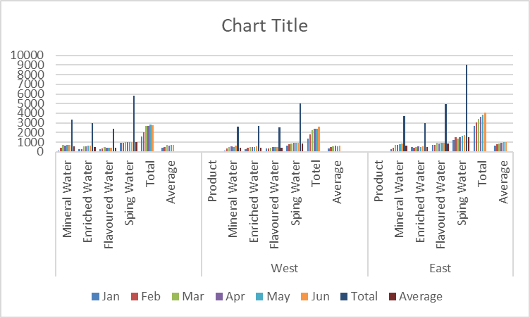

* The popularity of Spring Water across all regions emphasises its market dominance and potential for further growth.
* The significant difference in Flavoured Water sales between the East and other regions suggests cultural or taste preferences that could be leveraged in targeted marketing campaigns.
* Consistent sales of Mineral Water across regions highlight its position as a staple product with potential for steady revenue.
* The varying performance of Enriched Water indicates a need for further analysis to understand market positioning and opportunities for increased sales.

Conclusion

The analysis underscores the importance of understanding regional preferences and product performance to optimize sales strategies. Spring Water's dominance across regions indicates a strong market position, while the varying popularity of other products suggests opportunities for targeted growth and marketing.

Recommendations for Action

* Maximise Spring Water Sales: Increase production and marketing efforts for Spring Water, especially in the West, to capitalize on its strong market position.
* Targeted Marketing for Flavoured Water: Develop targeted marketing strategies for Flavoured Water in the East to enhance its sales and explore the potential for increasing its market share in other regions.
* Analyse Enriched Water's Market Position: Conduct market research to understand the lower sales figures for Enriched Water and develop strategies to improve its market presence.
* Customize Regional Marketing Strategies: Tailor marketing and product strategies to regional preferences to maximize sales performance and customer satisfaction across all regions.

Executive Summary

Our analysis reveals Spring Water as the top-performing product in all regions, with the East region leading in overall sales. Flavoured Water exhibits strong regional preferences, suggesting potential for targeted marketing. The report identifies opportunities for growth in the Enriched Water and Flavoured Water categories and recommends strategies to optimize sales and marketing efforts based on regional trends and product performance.